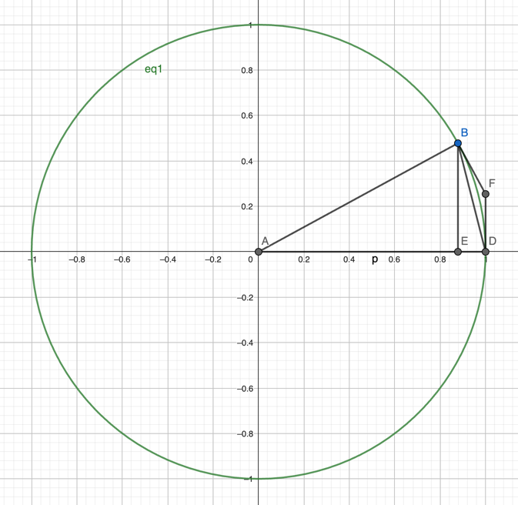

Graph description:

Center of Circle at point A (0,0)

B and D are points on the circle and BD lies on the x axis

BE is perpendicular to the x axis  
BF and DF are tangent lines of the circle at point B and D respectively